**Unlocking Automotive Trends with Data Analytics**

Key Questions:

We will explore and answer the following questions -

Part - 1

1. A new car manufacturer wants to introduce a new car and wants information about the top 5

most preferred car body types.

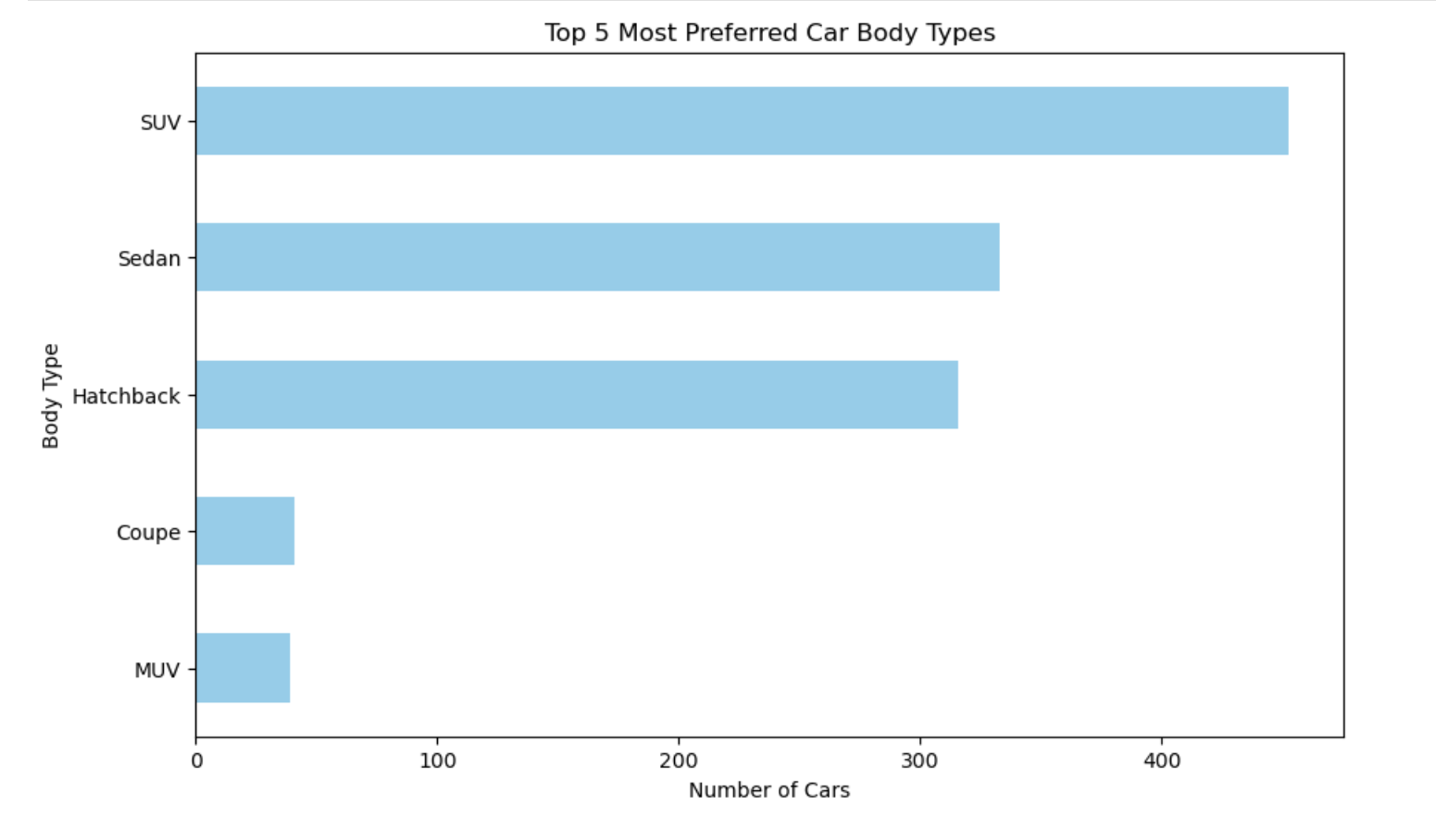

Interpretations:

* Top 5 Most Preferred Car Body Types are SUV, Sedan, Hatchback, Coupe, and MUV.

2. List all the details of cars that can adapt to various driving conditions such as normal,

comfort, eco, sport, and power mode. How many cars have all the above-mentioned features?

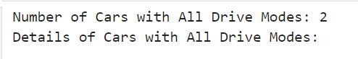

Interpretations:

* The number of Cars with All Drive Modes is 2.

3. Identify the top 10 car manufacturers based on the city mileage and display the result using a horizontal bar graph with the manufacturer on the y-axis and mileage on the x-axis.

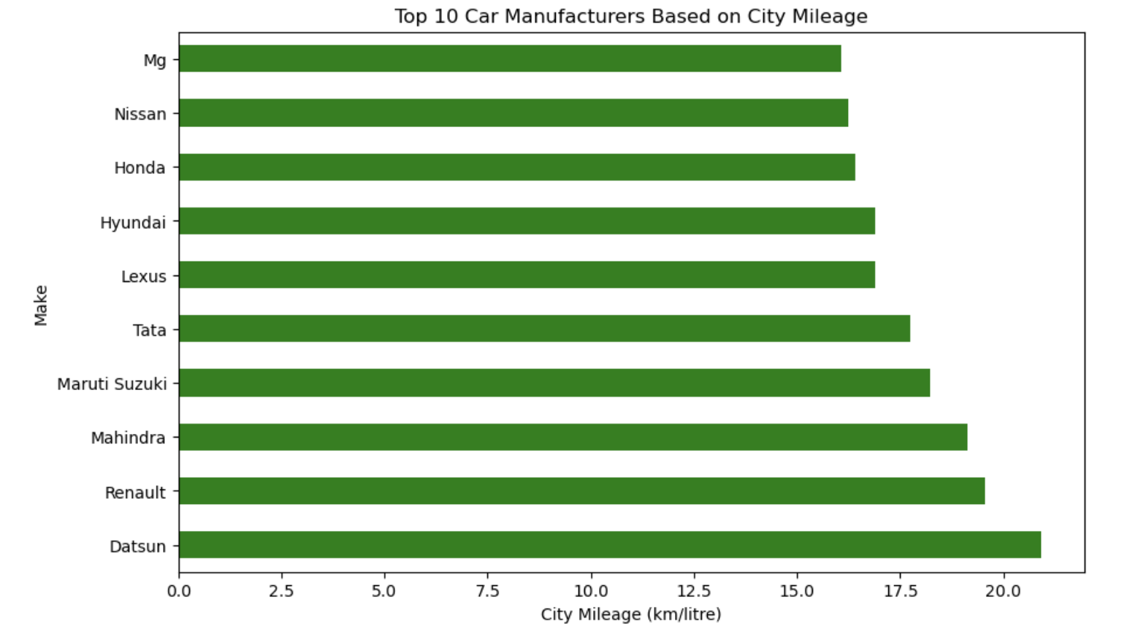

Interpretations:

* Top 10 Car Manufacturers Based on City Mileage are Datsun, Renault, Mahindra, Maruti Suzuki, Tata, Lexus, Hyundai, Honda, Nissan, Mg.

4. Identify the top 20 non-electric car manufacturers based on city mileage and display the

results using a bar graph similar to that in task 1.

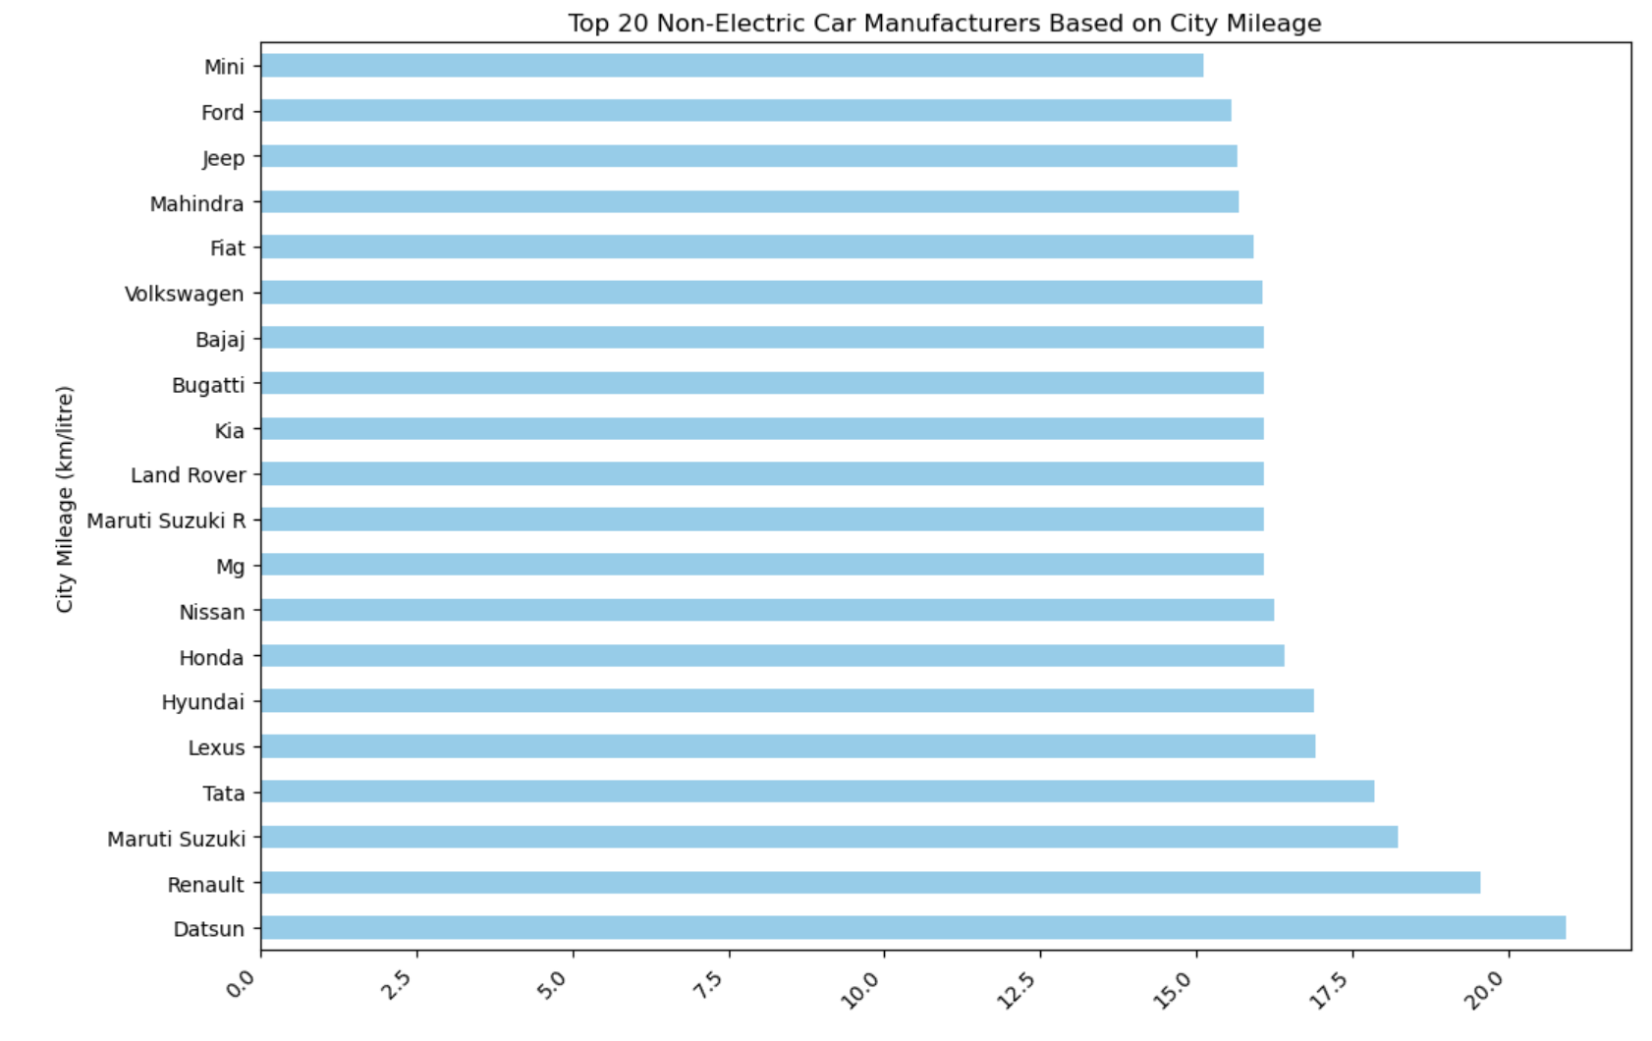

Interpretations:

* Top 20 Non-Electric Car Manufacturers Based on City Mileage are Datsun, Renault, Maruti Suzuki, Tata, Lexus, Hyundai, Honda, Nissan, Mg, Maruti Suzuki R, Land Rover, Kia, Bugatti, Bajaj, Volkswagen, Fiat Mahindra, Jeep, Ford, Mini.

5. Display the car mileages for the following four companies using a pivot table:

Hyundai, Mahindra, Renault, and Skoda

Create 4 separate pivot tables capturing the following details:

1. Mean of city mileage 2. Median of city mileage 3. Mean of highway mileage 4. Median of highway mileage

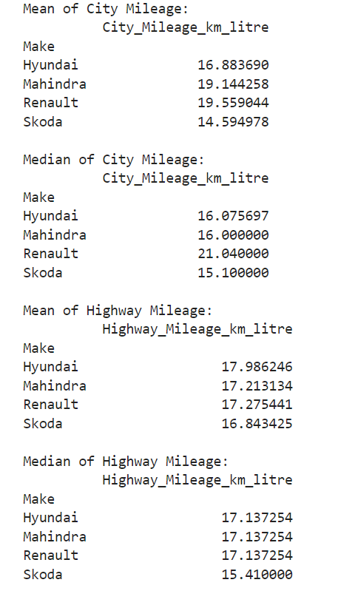

Interpretations:

* Renault has the highest Mean city mileage

* Renault has the highest Median city mileage

* Hyundai has the highest Mean highway mileage

* Hyundai, Mahindra, and Renault have the highest Median highway mileage

6. Display the mean and median values of city mileages of the following manufacturers, using a stacked column chart: Hyundai, Renault, Mahindra, and Skoda

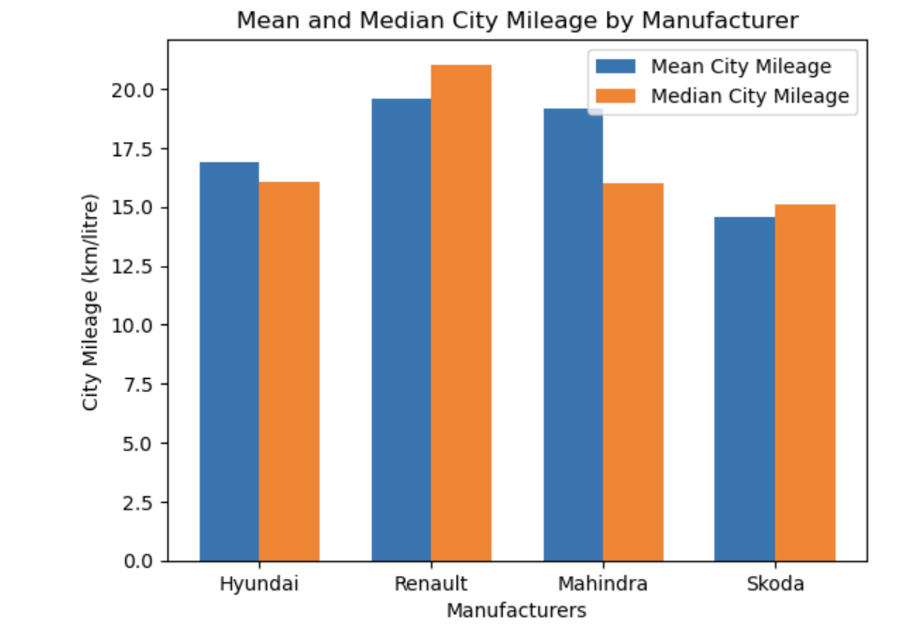

Interpretations:

* Renault has the highest Mean city mileage

* Renault has the highest Median city mileage

7. Display the average mileage (city and highway) of all manufacturers using a horizontal bar

chart, in ascending order of mileage.

Note: The missing values in the mileage column need to be filled with the mean value with

respect to the car makers and models.

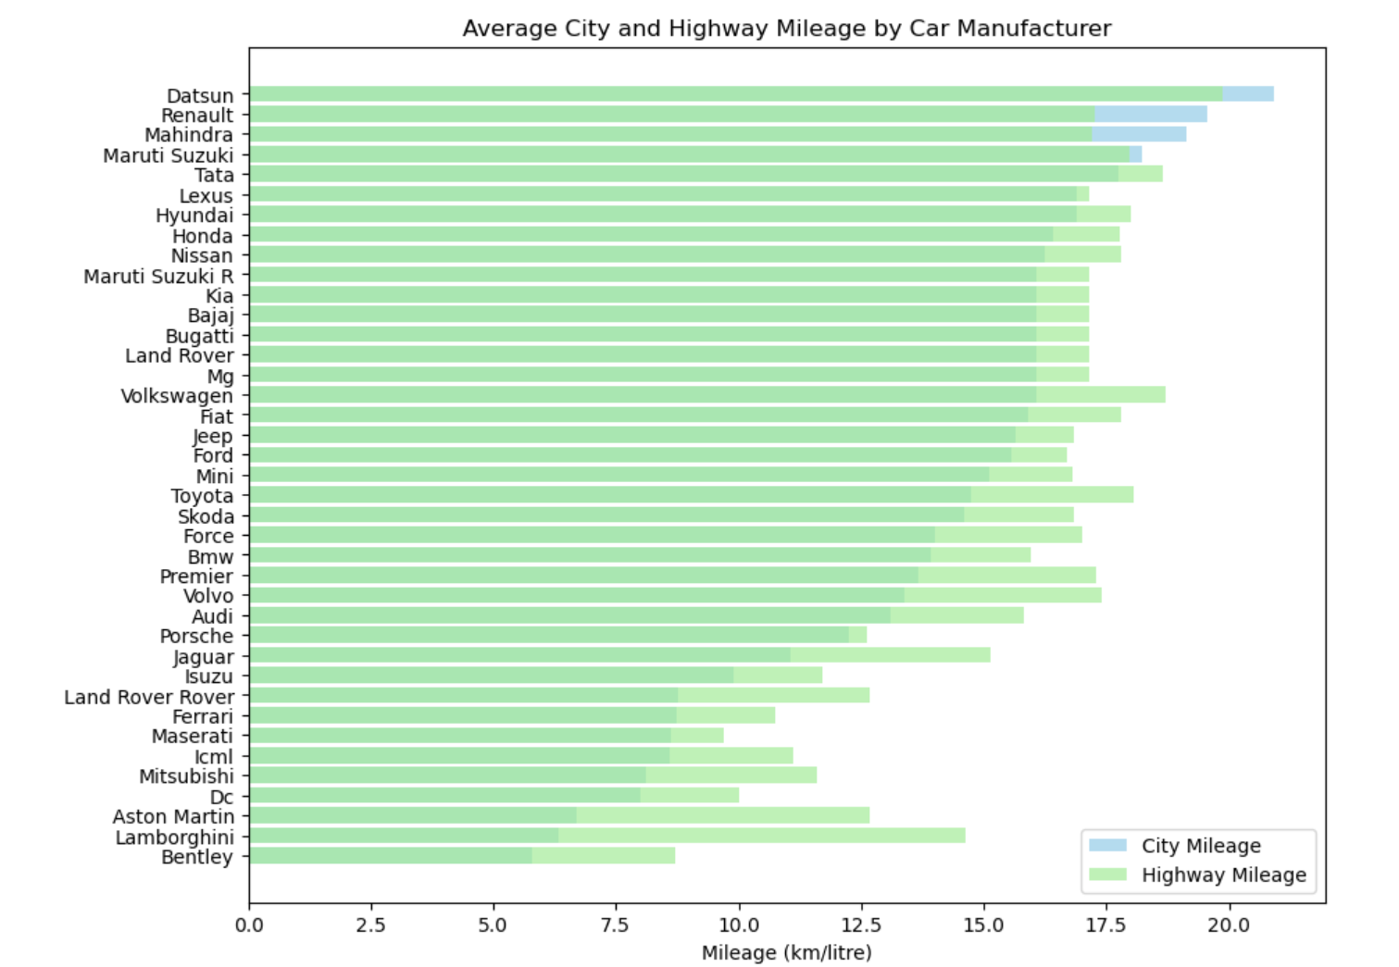

Interpretations:

* The chart visually presents a clear trend in mileage performance across different car manufacturers.

8. Plot a line chart to understand the relation between displacement and city mileage by

choosing the top 10 cars with the highest city mileage.

What do you infer from this graph? Are there any unusual observations? If yes, how would

Do you resolve these?

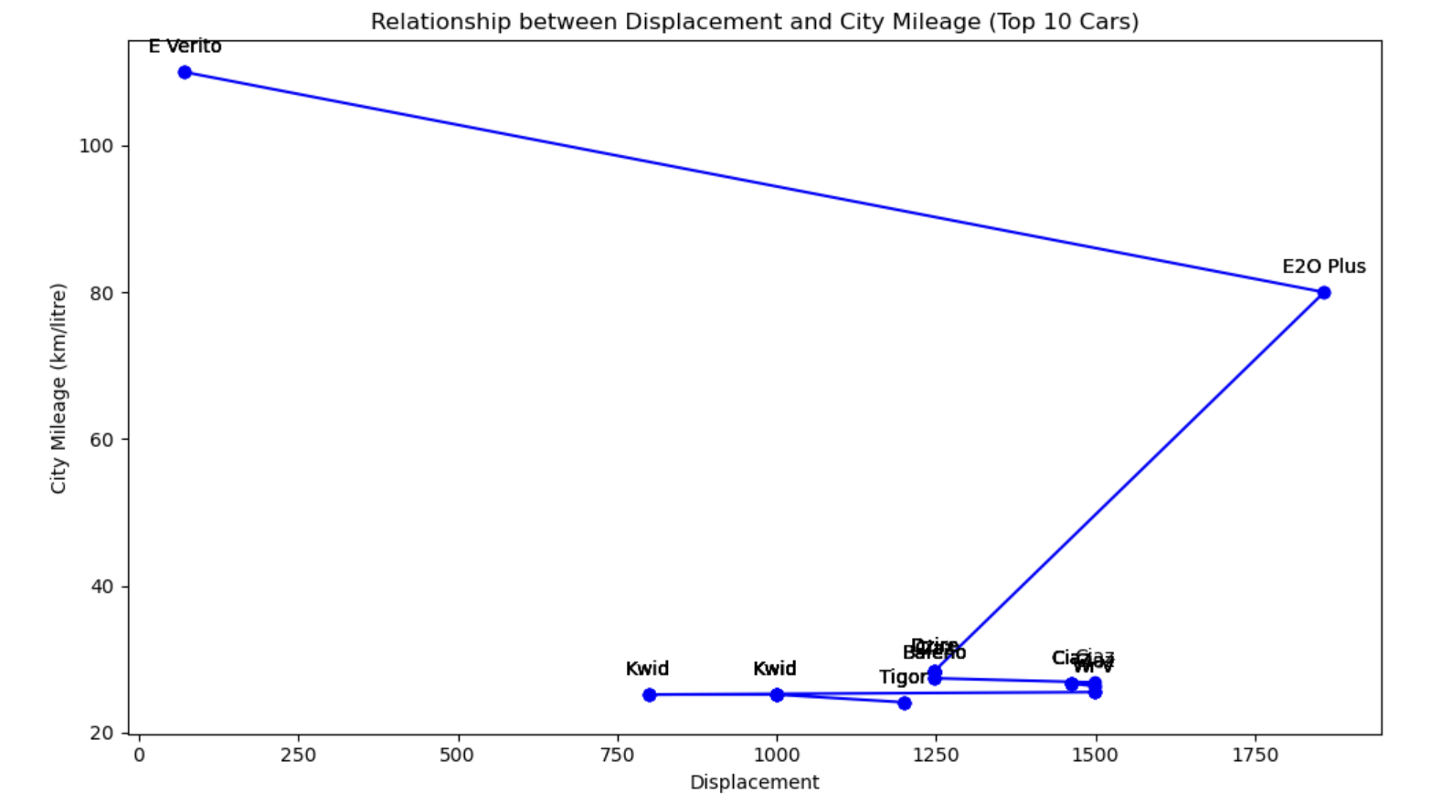

Interpretations:

* The E20 Plus car model has the highest city mileage and displacement.

9. Analyze the spread of fuel economy using a histogram for all car models of the following

manufacturers: Hyundai, Suzuki, Tata, and BMW

Which of these manufacturers has the most skewed mileage distribution?

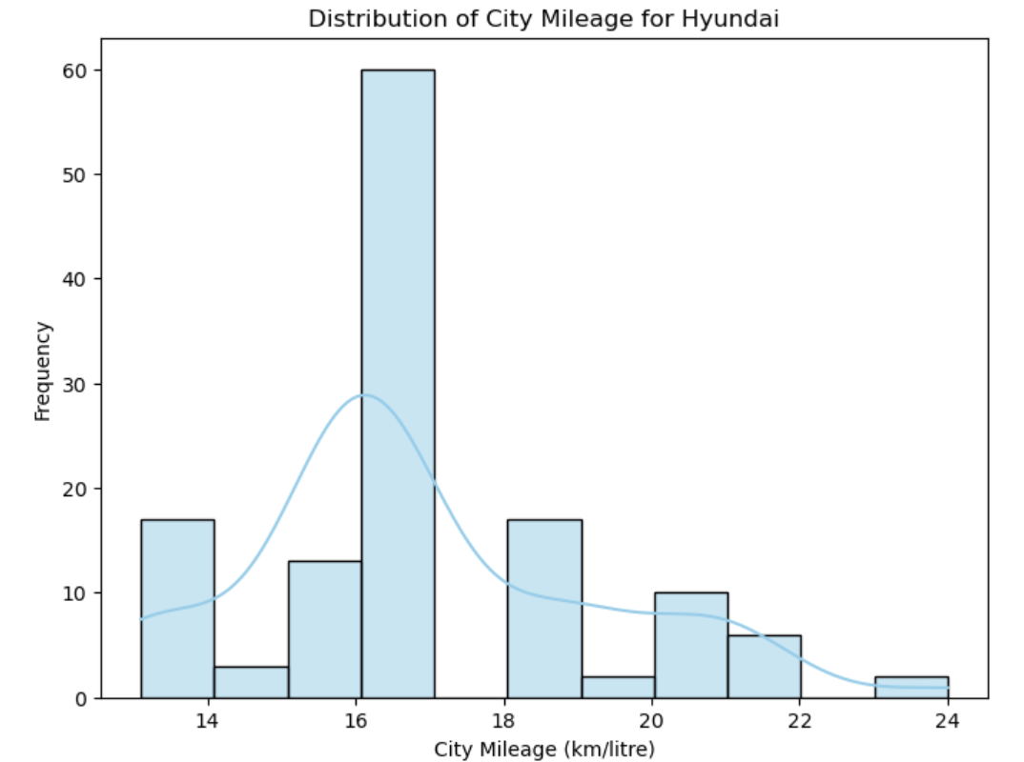 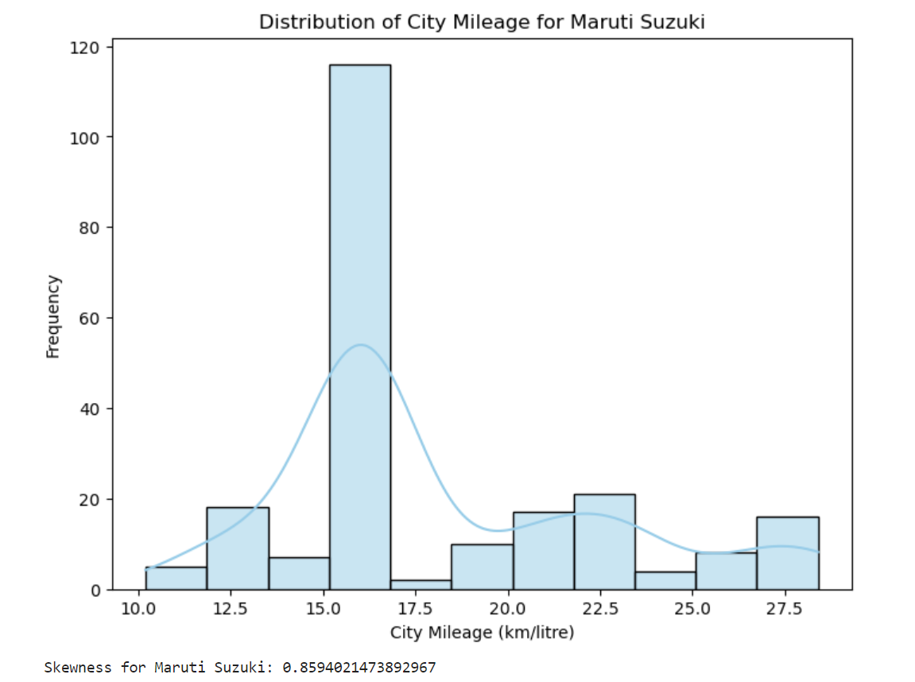

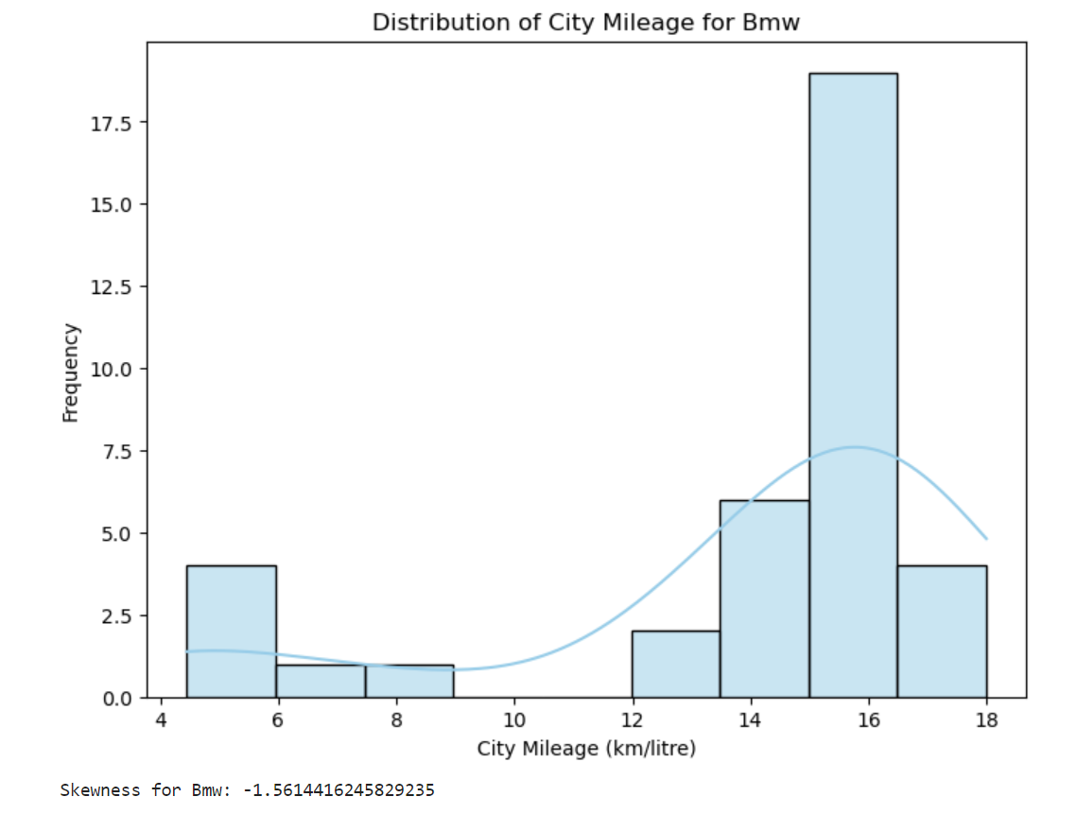

# Part - 2

1. Create another data frame that includes only the following columns from the data. Perform

missing value treatment for these columns, if required.

• Valves_Per_Cylinder, Kerb_Weight, Make, Displacement, Fuel_Tank_Capacity_litre, City_Mileage_km_litre, Highway_Mileage_km_litre, Power, Torque, Gross_Vehicle_Weight

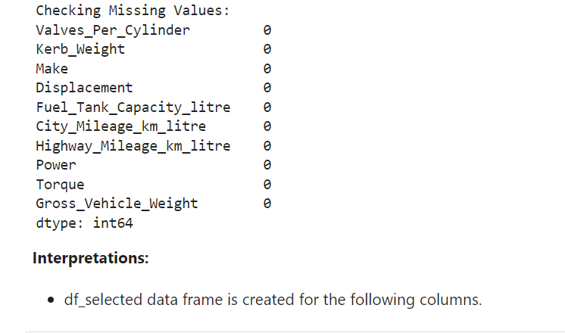

2. Preprocess the data in the following columns as specified.

• Kerb_weight: Remove "kg" and ensure the column is numerical. Convert the weight

in kilograms to pounds, by multiplying each value in the column with the number 2.2.

• Power: Sample data = 38PS @ 5500rpm. All entries of the column "Power" should

only contain the number 38 after cleaning.

• Torque: Sample data = 51Nm@4000rpm. The column "Torque" must only contain the

number 51 after cleaning. Perform this operation to all entries of the column and

ensure this column is converted to numerical type.

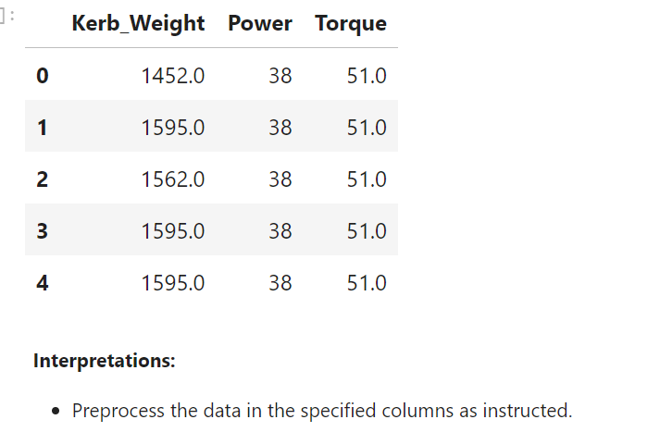

3. Compare the performance of cars based on factors such as displacement, cylinders, and

valves per cylinder, providing valuable insights for marketing and product development.

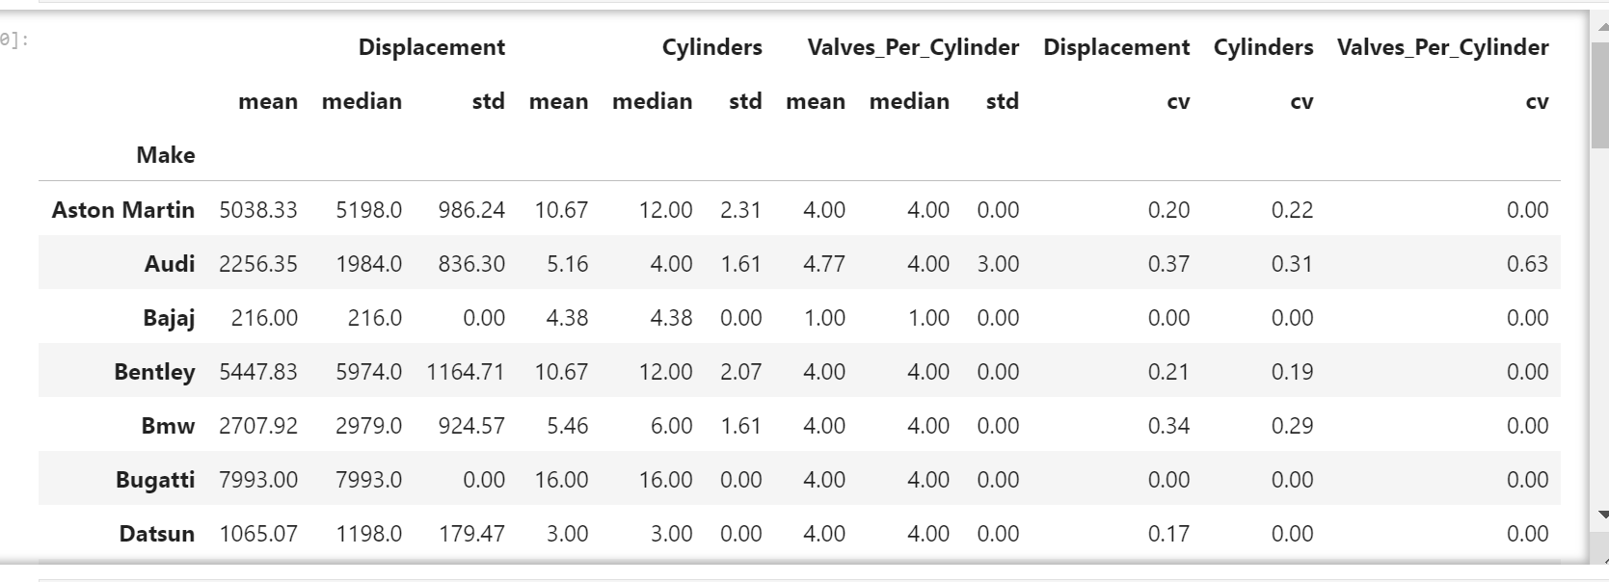

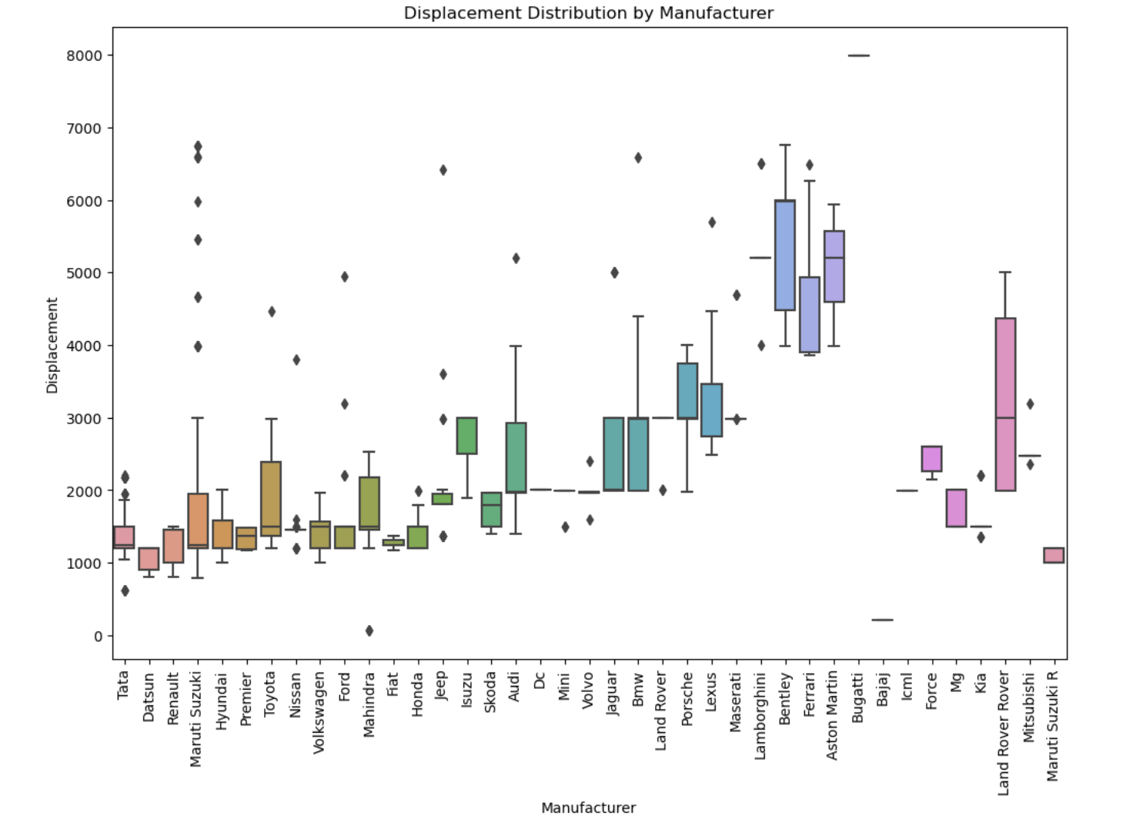

Interpretations:

* Marketing: Highlight the power and performance of high-displacement, high-cylinder cars (e.g., Lamborghini, Bugatti) to appeal to enthusiasts, while emphasizing fuel efficiency and city-friendly features for smaller-engine cars (e.g., Bajaj, Maruti Suzuki R) targeting urban consumers.

* Product Development: Consider introducing models with a diverse range of engine configurations, responding to market demands for both powerful, high-performance vehicles and fuel-efficient, city-friendly options to cater to a wider audience.

4. Identify at least three features that affect the mileage (using correlation analysis) of cars from the following manufacturers: Renault, Toyota, and Honda.

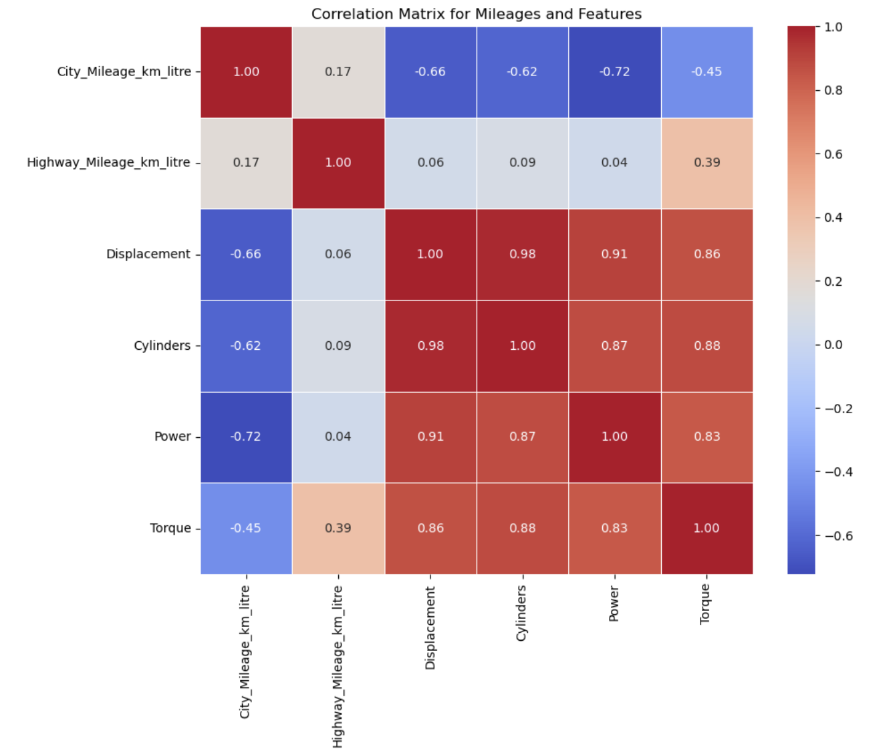

Interpretations:

* Power and Torque have a negative correlation with mileage.

5. Compare the performance of cars based on factors like kerb weight and gross vehicle weight.

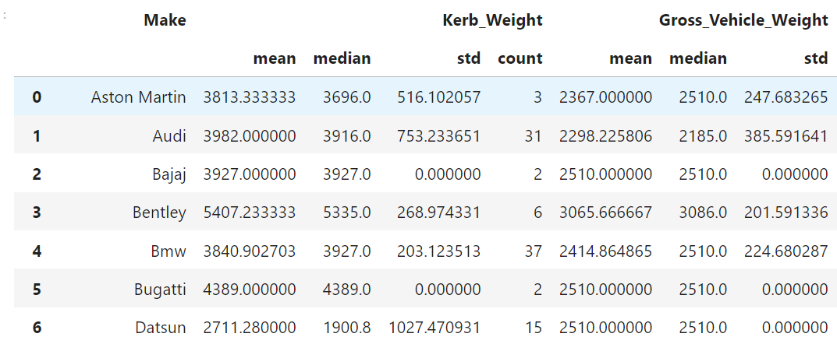

Interpretations:

* Calculated and displayed the mean, median, standard deviation, and coefficient of variation

for each manufacturer.

# Part - 3

1. Examine the presence of safety features such as ABS, airbags, and hill assist, to assess the safety standards of various car models.

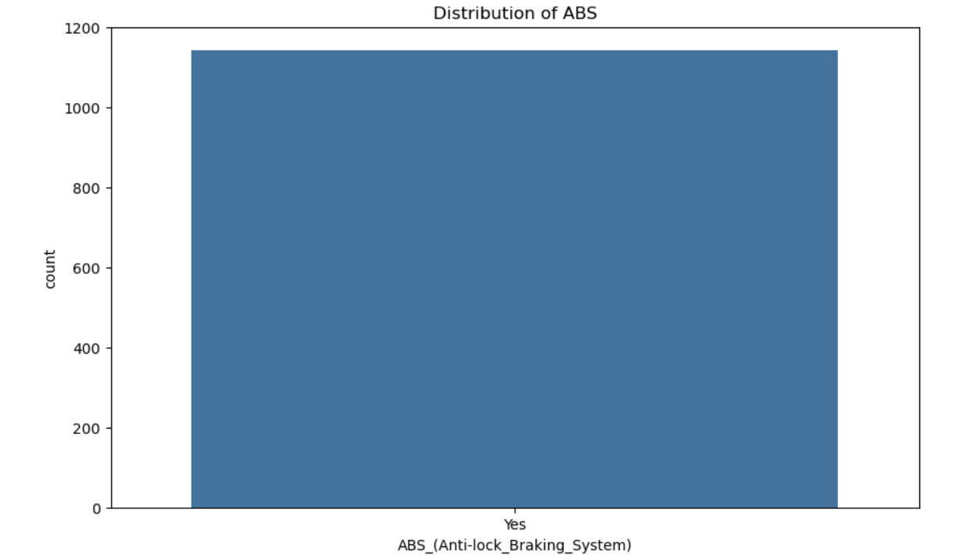 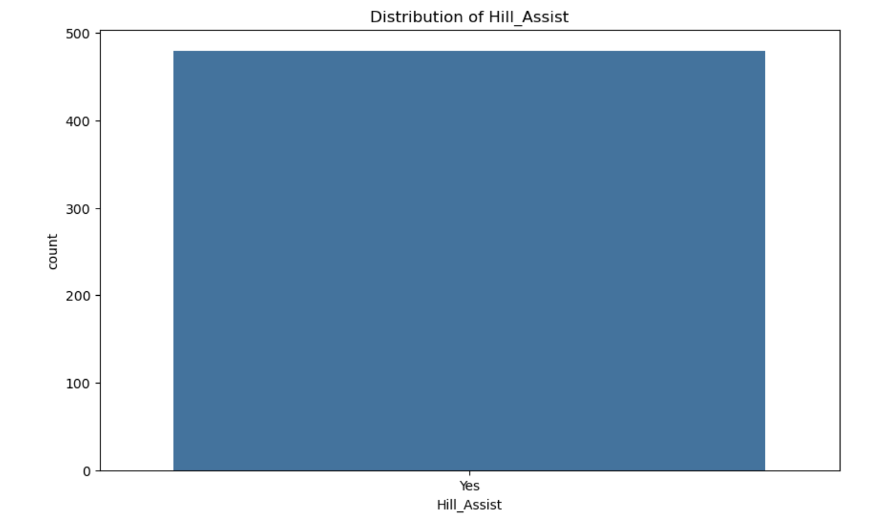

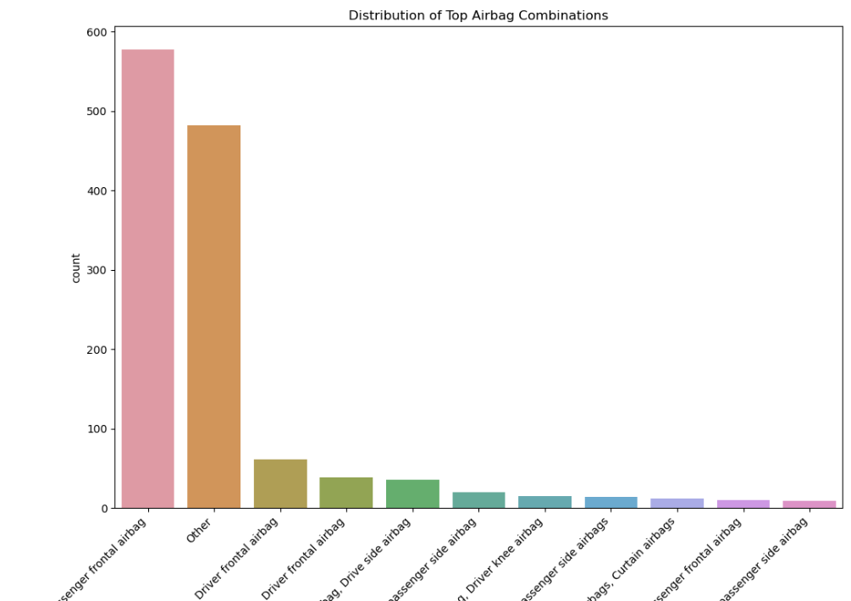

Interpretations:

* All cars have ABS.

* Airbag has a wide range of verities.

* Original 480 cars have hill assist.

2. Explore seating capacity, central locking, and child safety locks to understand user comfort and family-friendly features.

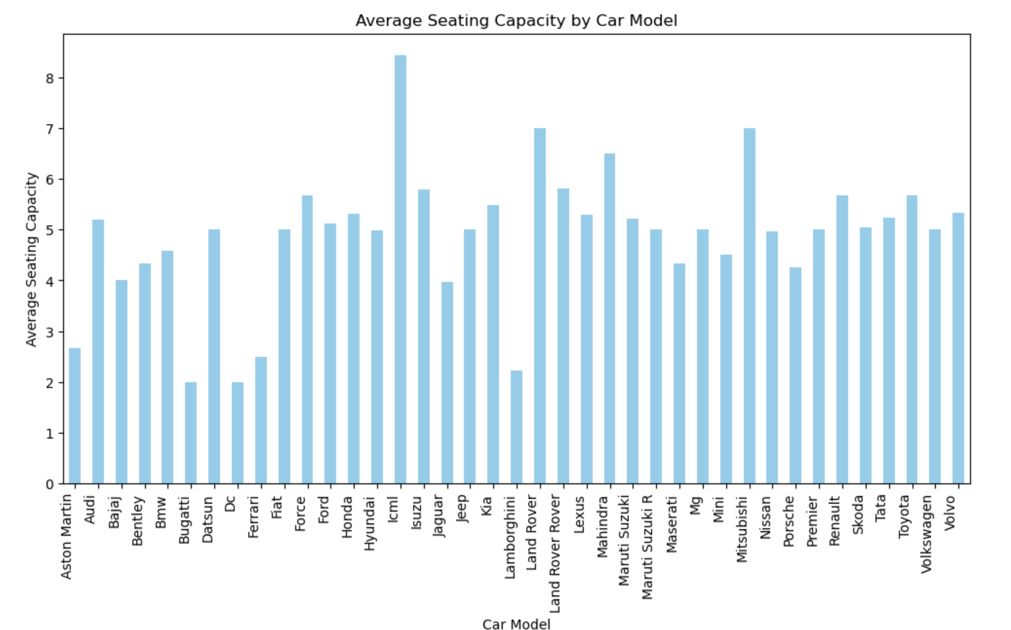

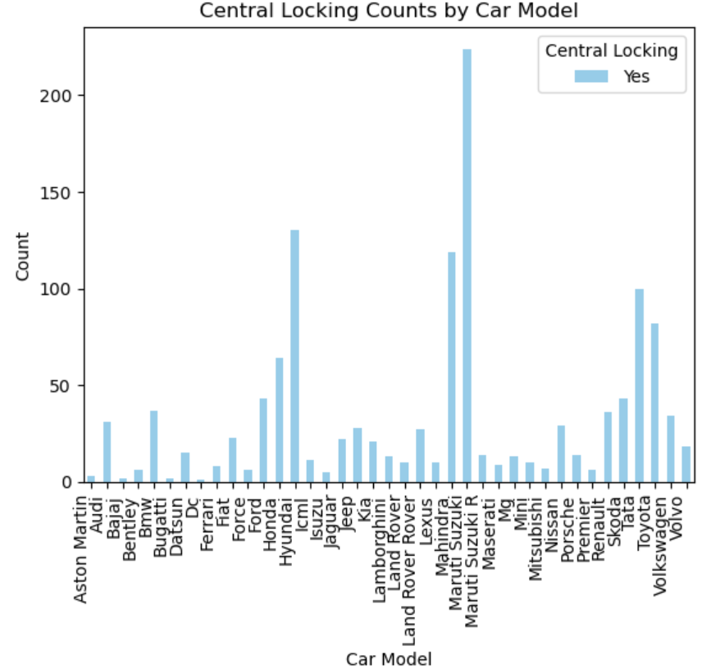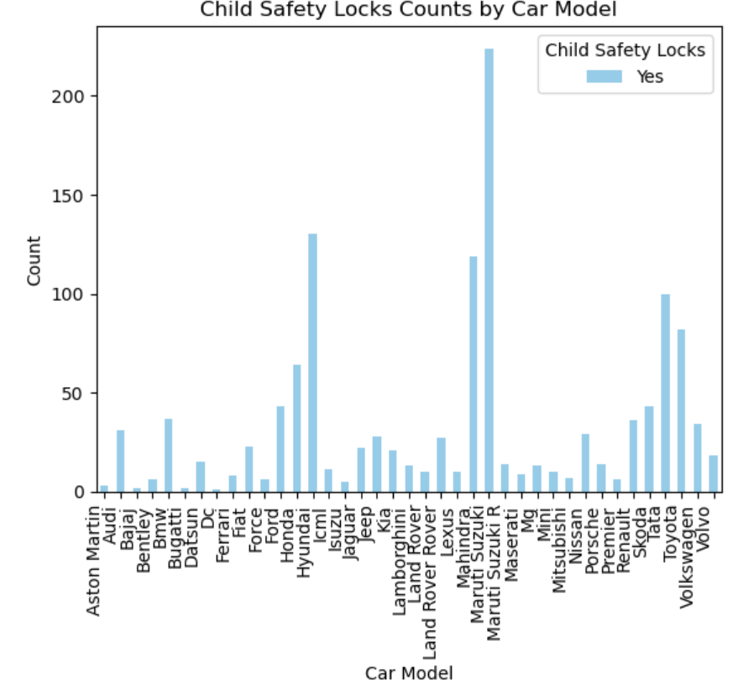

Interpretations:

* I have explored and displayed seating capacity, central locking, and child safety locks to understand user comfort and family-friendly features.

3. Investigate the presence of high-speed alerts, seat belt reminders, and door ajar warnings to assess the integration of safety and convenience features.

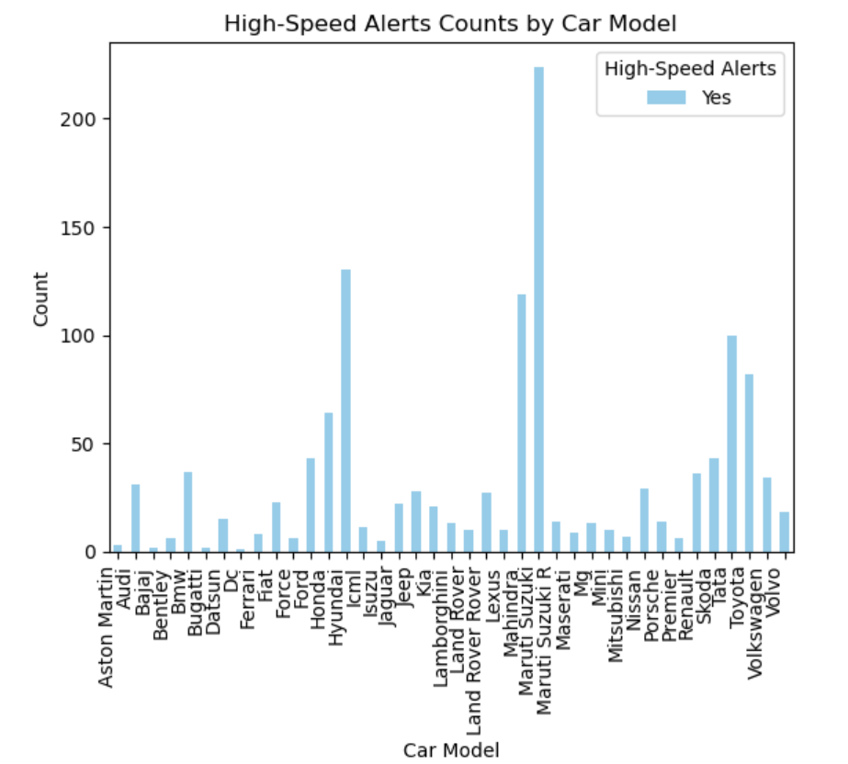 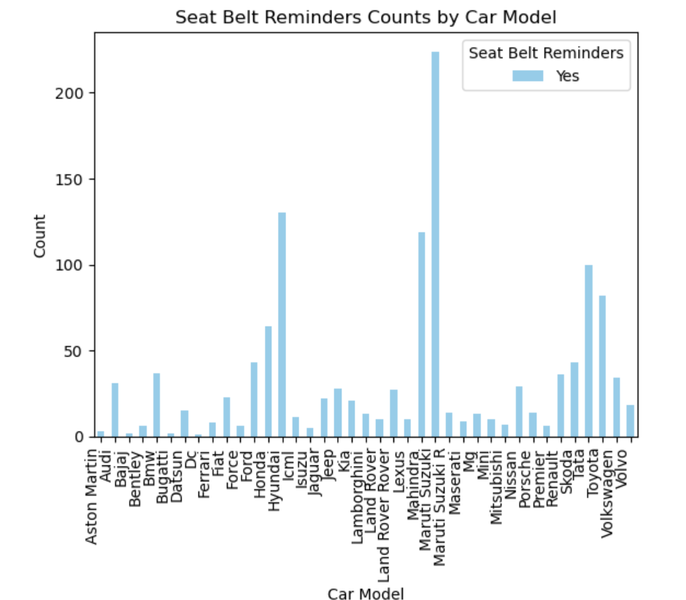

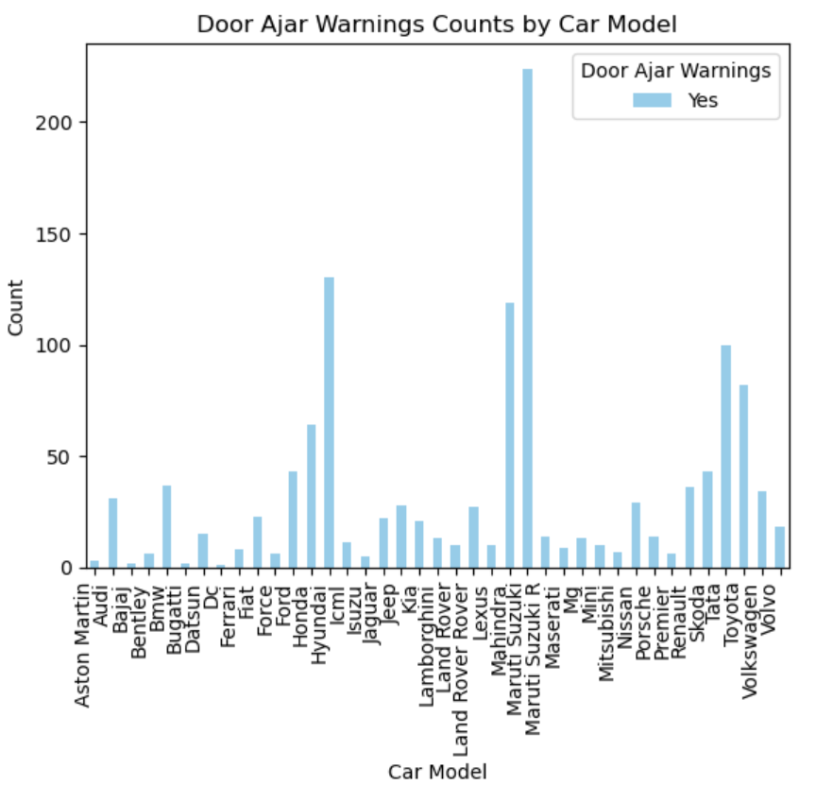

Interpretations:

* I have Investigated the presence of high-speed alerts, seat belt reminders, and door-ajar warnings to

assess the integration of safety and convenience features.

4. Analyze the dimensions of cars (height, length, width) to understand size preferences and

market demands, aiding in product planning.

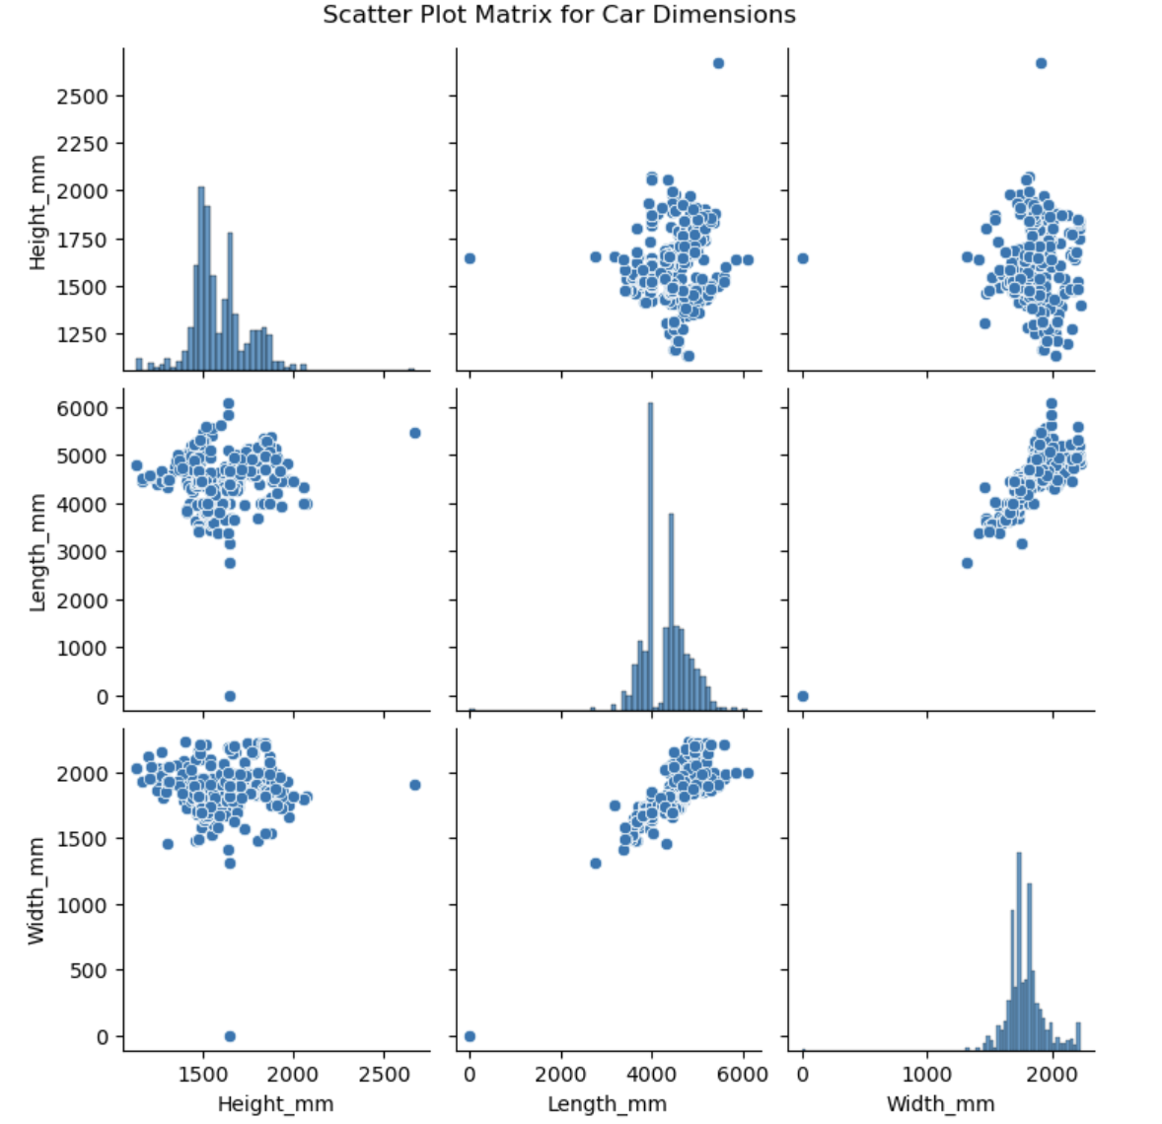

Interpretations:

* The average height of cars in the dataset is approximately 1592.54 mm, with a moderate variation of 151.61 mm. Heights range from a minimum of 1136.00 mm to a maximum of 2670.00 mm, indicating diversity in car sizes.

* The average length of cars is around 4296.88 mm, with a notable standard deviation of 476.61 mm. The dataset spans from a minimum length of 4.64 mm to a maximum of 6092.00 mm, reflecting a wide range of car lengths.

* The average width of cars is approximately 1788.55 mm, with a standard deviation of 150.22 mm. Widths vary from a minimum of 1.84 mm to a maximum of 2226.00 mm, suggesting diversity.

**Summarize all interpretations**

**1. Car Body Types:**

**• The top 5 most preferred car body types are SUV, Sedan, Hatchback, Coupe, and MUV, indicating diverse consumer preferences.**

**2. Drive Modes:**

**• There are 2 cars with all drive modes.**

**3. Top 10 Car Manufacturers (City Mileage):**

**• Datsun, Renault, Mahindra, Maruti Suzuki, Tata, Lexus, Hyundai, Honda, Nissan, Mg are the top 10 car manufacturers based on city mileage.**

**4. Top 20 Non-Electric Car Manufacturers (City Mileage):**

**• Datsun, Renault, Maruti Suzuki, Tata, Lexus, Hyundai, Honda, Nissan, Mg, Maruti Suzuki R, Land Rover, Kia, Bugatti, Bajaj, Volkswagen, Fiat Mahindra, Jeep, Ford, Mini are the top 20 non-electric car manufacturers based on city mileage.**

**5. City and Highway Mileage:**

**• Renault has the highest mean and median city mileage.**

**• Hyundai has the highest mean highway mileage, while Hyundai, Mahindra, and Renault have the highest median highway mileage.**

**6. Mileage Trends:**

**• The chart visually presents a clear trend in mileage performance across different car manufacturers.**

**7. E20 Plus Model:**

**• The E20 Plus car model has the highest city mileage and displacement.**

**8. Mileage Distribution:**

**• BMW manufacturers have the most skewed mileage distribution.**

**9. DataFrame Operations:**

**• df_selected data frame is created for specified columns.**

**• Data is preprocessed in the specified columns as instructed.**

**10. Market Analysis:**

**• Market demands suggest a strategy of offering high-performance models (e.g., Bugatti) for enthusiasts and fuel-efficient, city-friendly options (e.g., Bajaj, Maruti Suzuki R) for urban consumers.**

**11. Product Development Recommendations:**

**• Consider introducing models with a diverse range of engine configurations to cater to both powerful, high-performance vehicles and fuel-efficient, city-friendly options.**

**12. Correlation Analysis:**

**• Power and Torque show a negative correlation with mileage.**

**13. Manufacturer Statistics:**

**• Calculated and displayed the mean, median, standard deviation, and coefficient of variation for each manufacturer.**

**14. Safety Features:**

**• All cars have ABS, and airbags have a wide range of varieties.**

**15. User Comfort and Safety Analysis:**

**• Explored and displayed seating capacity, central locking, and child safety locks to understand user comfort and family-friendly features.**

**16. Alert Systems Investigation:**

**• Investigated the presence of high-speed alerts, seat belt reminders, and door-ajar warnings to assess the integration of safety and convenience features.**

**17. Car Dimensions Analysis:**

**• Analyzed the dimensions (height, length, width) to understand size preferences and market demands, aiding in product planning. The dataset reflects diversity in car sizes, lengths, and widths.**

**Final Business Recommendation:**

**1. Diverse Product Portfolio:**

**• The market demands a diverse product portfolio that caters to various consumer preferences. Consider offering a mix of high-performance models and fuel-efficient, city-friendly options to appeal to a wider audience.**

**2. Fuel Efficiency Focus:**

**• Emphasize fuel efficiency in product development to align with the market trend. The analysis highlights Renault as a manufacturer with consistently high city mileage. Leveraging this strength and focusing on improving highway mileage can enhance the brand's appeal.**

**3. Safety and Comfort Features:**

**• Continue prioritizing safety and user comfort features. The analysis of safety features, seating capacity, and child safety locks underscores their significance in influencing consumer choices. Strengthening these aspects can enhance the overall appeal of the product.**

**4. Alert Systems Integration:**

**• Integrate advanced alert systems, including high-speed alerts, seat belt reminders, and door-ajar warnings, into future models. This can enhance the overall safety and convenience features of the vehicles, contributing to a positive consumer experience.**

**5. Market Positioning Strategies:**

**• Use the insights from market analysis to strategically position the brand. Highlighting strengths, such as top city mileage performance, can be leveraged in marketing and branding efforts to differentiate the brand in a competitive market.**

**6. Engine Configuration Variety:**

**• Respond to market demands for engine variety by introducing models with diverse engine configurations. This includes addressing the preferences of both performance enthusiasts (e.g., Bugatti) and urban consumers seeking fuel-efficient options (e.g., Bajaj, Maruti Suzuki R).**

**7. Consumer Communication:**

**• Communicate effectively with consumers about the diversity of the product lineup, safety features, and fuel efficiency. Transparent and informative communication can build trust and resonate with different target segments.**

**8. Continuous Data Monitoring:**

**• Implement a system for continuous monitoring and analysis of market trends, consumer preferences, and competitor activities. This will enable the business to adapt quickly to changing market dynamics and make informed decisions.**

**9. Collaboration Opportunities:**

**• Explore collaboration opportunities with technology partners to enhance in-car technologies, safety features, and overall user experience. Collaborations can bring innovative solutions to the market and strengthen the brand's competitiveness.**

**10. Sustainability Considerations:**

**• Given the growing emphasis on sustainability, evaluate opportunities for introducing electric or hybrid models. This aligns with global trends and may open up new markets and consumer segments.**

**In conclusion, the business should adopt a customer-centric approach, continuously innovate, and adapt to market dynamics to stay competitive in the automotive industry. The recommendations provided aim to guide strategic decisions for product development, marketing, and overall brand positioning.**

**THANK YOU**